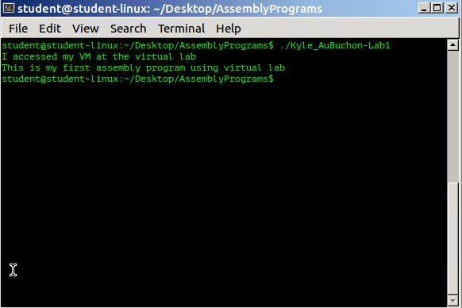

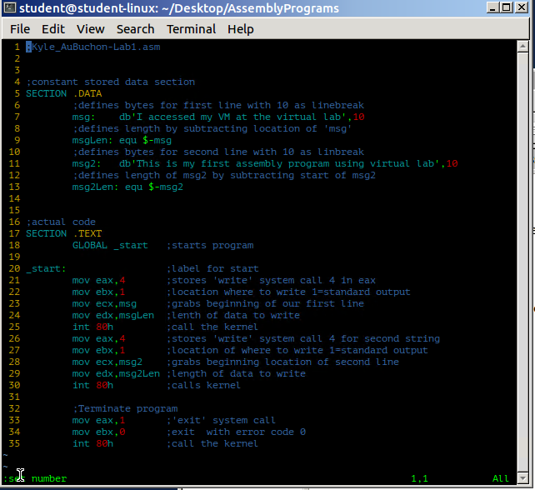

;Kyle_AuBuchon-Lab1.asm

;constant stored data section

SECTION .DATA

;defines bytes for first line with 10 as linebreak

msg**:** db'I accessed my VM at the virtual lab'**,**10

;defines length by subtracting location of 'msg'

msgLen**:** equ **$-**msg

;defines bytes for second line with 10 as linbreak

msg2**:** db'This is my first assembly program using virtual lab'**,**10

;defines length of msg2 by subtracting start of msg2

msg2Len**:** equ **$-**msg2

;actual code

SECTION **.TEXT**

GLOBAL _start ;starts program

_start**:** ;label for start

**mov** **eax,**4 ;stores 'write' system call 4 in eax

**mov** **ebx,**1 ;location where to write 1=standard output

**mov** **ecx,**msg ;grabs beginning of our first line

**mov** **edx,**msgLen ;lenth of data to write

**int** 80h ;call the kernel

**mov** **eax,**4 ;stores 'write' system call 4 for second string

**mov** **ebx,**1 ;location of where to write 1=standard output

**mov** **ecx,**msg2 ;grabs beginning location of second line

**mov** **edx,**msg2Len ;length of data to write

**int** 80h ;calls kernel

;Terminate program

**mov** **eax,**1 ;'exit' system call

**mov** **ebx,**0 ;exit with error code 0

**int** 80h ;call the kernel